XBRMS WEB INTERFACE USER GUIDE

**Revision History**

|  |  |  |  |
| --- | --- | --- | --- |
| **Rev** | **Date** | **Author** | **Description** |
| 1.0 | 5/1/2012 | Arkady Glabek | Release Version |
| 1.1 | 8/16/2012 | Iwona Glabek | Changes to the health monitoring page and new performance metrics page. |
| 1.1 | 10/1/2012 | Stephen Beecroft | Edit |
| 1.5 | 02/05/2012 | Iwona Glabek | Added 1.4 and 1.5 functionality |
| 1.5 | 02/11/2013 | Slava Minyailov | Added 1.6 functionality |

**Document Approvers & Sign-Off**

|  |  |  |  |
| --- | --- | --- | --- |
| **Date** | **Approver** | **Role** | **Document Accept/Reject** |
| 5/1/2012 | Ric Merrifield | Release Manager | Accept |
| 5/11/2012 | John Stiehl | Release Manager | Accept |

**Table of Contents**

1 Introduction 4

1.1 Purpose 4

1.2 Scope 4

1.3 Assumptions and Constraints 4

1.4 Definitions 4

2 Available Functionality 5

2.1 System Health 5

2.1.1 Adding New Applications to Monitor 6

2.1.2 Removing Application to Monitor 7

2.1.3 Deactivating Monitored Application 7

2.1.4 Activating a Previously Deactivated Application 8

2.1.5 Refreshing Monitored Application Status 8

2.1.6 Accessing Readers Health Status 8

2.1.7 Accessing Performance Metrics 9

2.2 Readers Health 10

2.2.1 Reader Commands 11

2.3 Assign Readers 12

2.4 xBRC Configuration Edit 12

2.5 Stored XBRC Configurations 15

2.5.1 Adding New Stored Configuration 16

2.5.2 Deploying Stored Configuration 17

2.5.3 Downloading Stored Configuration 18

2.5.4 Removing Stored Configuration 18

2.6 Edit XBRMS Properties 19

2.7 XBRMS server chooser 20

# Introduction

## Purpose

This document describes functionality available in the xBRMS UI.

## Scope

This document provides instructions on how to use the xBRMS UI screens accessible from the xBRMS UI **Home Page** http://<xBMS_IP>:8080/XBRMS

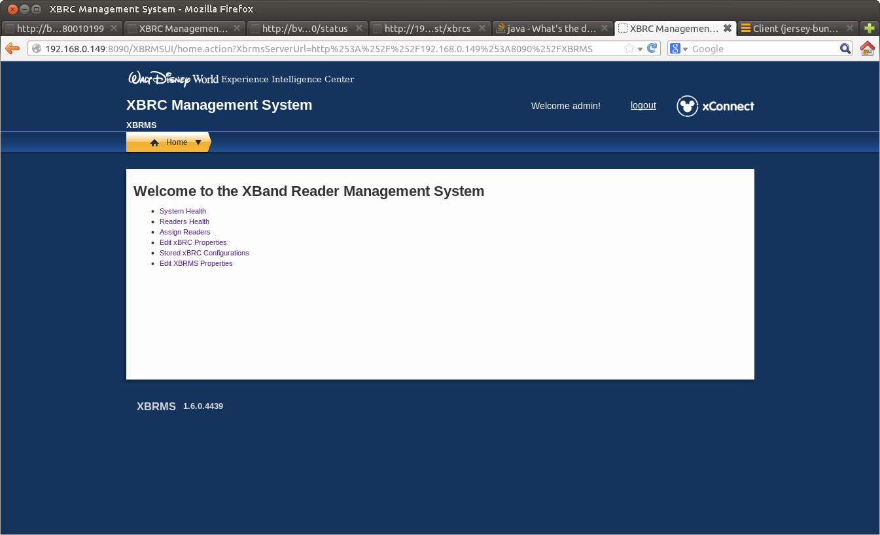

Figure : Home Page

## Assumptions and Constraints

For the first version of this application Mozilla Firefox is the recommended browser.

## Definitions

|  |  |
| --- | --- |
| **Terms** | **Definition** |
| xBRMS | xBand Reader Management System |
| xBRC | xBand Reader Controller |

# Available Functionality

## System Health

The System Health page shows the status of all monitored applications.

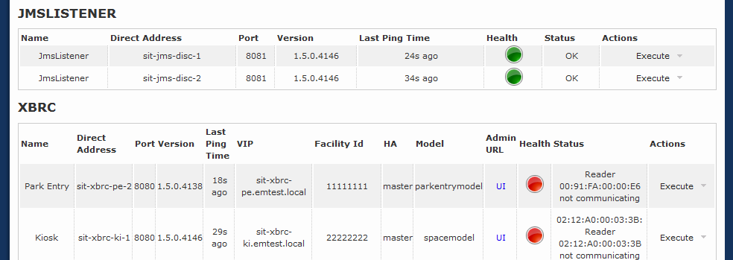

Figure : System Health Page

The System Health page consists of a table grouped by the type of application. Each application shows some common columns listed below as well as optional columns specific for that application.

Columns common to all monitored applications:

| **Column** | **Description** |
| --- | --- |
| Name | Instance name of the monitored application. |
| Direct Address | IP address or hostname of the monitored application. |
| Port | IP Port used to make REST calls to the monitored application. |
| Version | The version of the monitored application. |
| Last Ping Time | How long ago was xBRMS able to contact a monitored application. |
| Health | Green – healthy, Yellow – functioning but with errors, Red – critical errors exists, may not be functioning |
| Status | Description of the warning or error. |
| Execute:Details | More information on the application. |
| Execute:Delete | Click to remove this monitored application from the xBRMS. The application will still run, but it will no longer be monitored Additional data collected for this application will be permanently deleted as well. |
| Execute:Deactivate | Click to deactivate this health item. Deactivating a health item removes it from the health monitoring page, but doesn’t delete it from the XBRMS database. The item is marked as inactive and its additional data, if collected, is preserved. |

The following table describes table columns shown on the System Health page that are specific to the xBRC application.

|  |  |
| --- | --- |
| **Column** | **Description** |
| VIP | Virtual IP |
| HA | High Availability status. |
| Facility Id | The OneSource unique facility id, also known as venue id. |
| Model | The xBRC model type such as attraction, space, parkentry. |
| Admin URL | Link to the xBRC administration web interface. |

### Adding New Applications to Monitor

The xBRMS is capable of auto-discovering xBRC applications using the JMS message of xbrc.type = “DISCOVERY”. This message is periodically send out by all xBRC applications. Other applications, such as IDMS, must be added manually. Follow the steps below to add a new application to monitor.

1. From the Home Page navigate to the **System Health** page.
2. Click **Add Item** at the bottom of the page. The **Add Health Item** dialog will show.  
     
   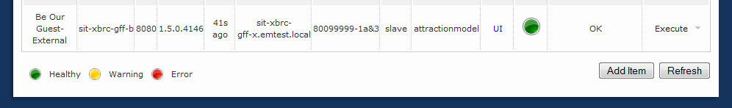

Figure : Add Item Button

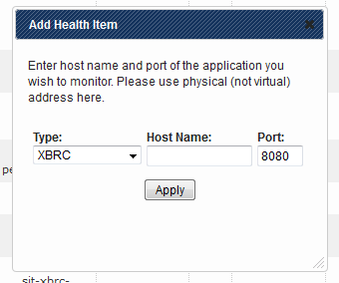

Figure : Add Health Item Dialog

1. Under **Type,** select the type of application to monitor.
2. Enter the IP address and port.
3. Press **Apply**.

### Removing Application to Monitor

To stop monitoring an application and permanently remove all additional data collected for that application, click **Execute:Delete** button associated with the application in the **Actions** column.

**NOTE:** This operation does not uninstall the application itself.

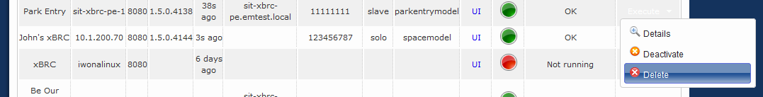

Figure : Removing Monitored Application

### Deactivating Monitored Application

To stop monitoring an application but preserve all additional data collected for that application, click the **Execute:Deactivate** button associated with the application in the **Actions** column.. Note that this operation does not stop the application itself.

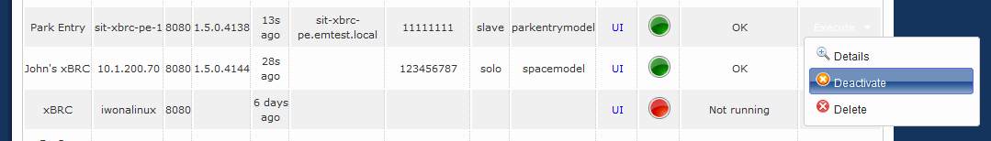

Figure 6: Deactivating Monitored Application

### Activating a Previously Deactivated Application

To activate a previously deactivated application, follow the steps described in Adding New Application to Monitor. If the application you are adding has been monitored by XBRMS before and has simply been deactivated, it will be activated. Otherwise, it will be added.

### Refreshing Monitored Application Status

All monitored applications are periodically contacted by the xBRMS to see if they are still alive and to retrieve their health status. To force a refresh, press **Refresh**at the bottom of the **System Health** page.

**NOTE:** Using the web browser refresh functionality does not force a refresh of the monitored applications’ status.  


Figure 7: Refresh Button

### Accessing Readers Health Status

To access information on a given xBRC’s readers’ health status, click on that xBRC’s **Health** icon or the **Execute:Details** button.

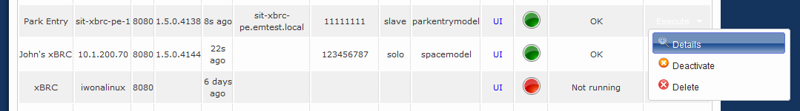

Figure 9: Details Button

The first tab on the page you’ll be taken to is the readers’ health page:

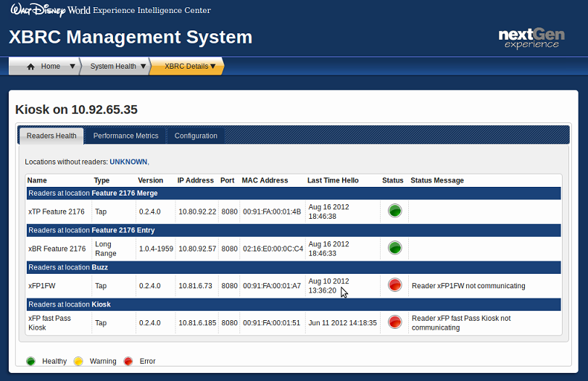

Figure 10: xBRC Details Page – Readers View

### Accessing Performance Metrics

xBRMS collects performance metrics data for each monitored xBRC. To access that data, click the icon in the **Health** column for an xBRC and go to the Performance Metrics tab.

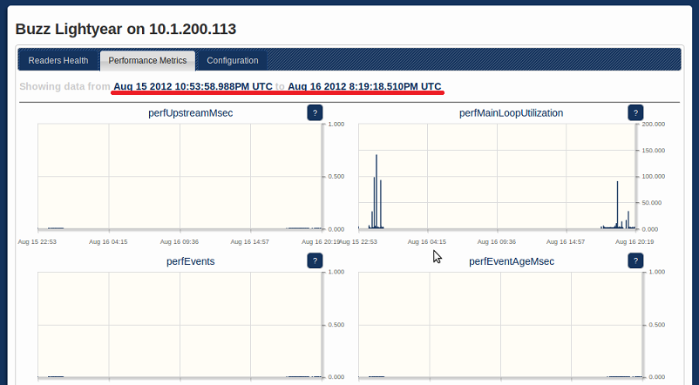

Figure 11: xBRC Details Page – Performance Metric Page

Each xBRC collects its performance metrics data in ten-minute intervals. xBRMS pulls for that data and persists the min, mean, and max for each metric. The performance metrics page shows performance data for the last 24 hours. The time window moves forward every ten minutes.

To view a larger version of a graph, click anywhere inside that graph.

## Readers Health

Readers centric health status monitoring page. Groups readers by xBRC and location. This page offers two views: a **Grid View** and a **List View**. The **Grid View** is more concise. The **List View** offers more information.

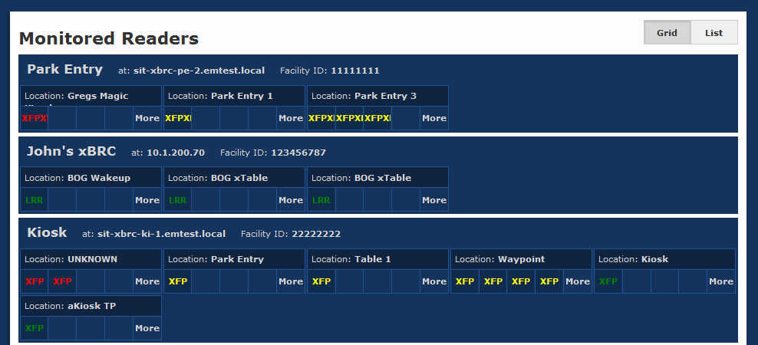

Figure 12: Monitored Readers Health Page – Grid View

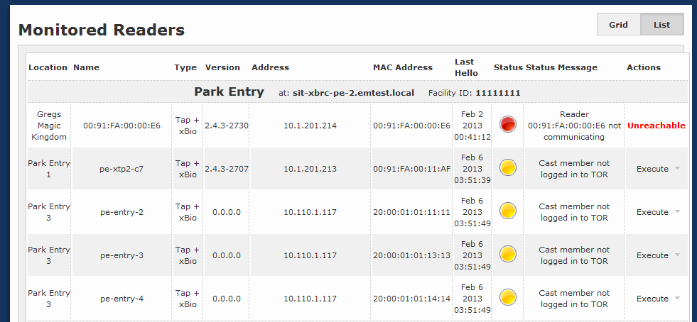

Figure 13: Monitored Readers Health Page – List View

### Reader Commands

There are several commands that can be executed on a reader from this page:

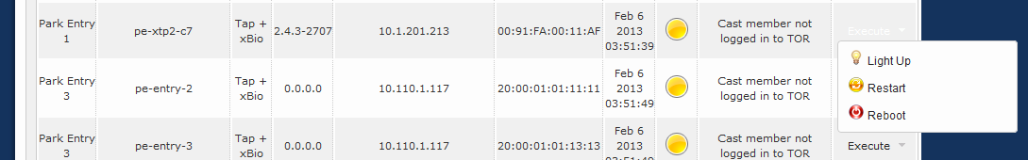

Figure 14: Monitored Readers Health Page – Reader Commands

#### Light Up Reader Command

This command plays a special yellow media sequence on Touch point readers to help with visual identification.

#### Restart Reader Command

This command restarts reader’s application.

#### Reboot Reader Command

This command reboots reader’s server.

## Assign Readers

Readers that are not already configured to say HELLO to a particular xBRC use an SRV record to discover an xBRMS to report to for assignment. Once those lost/unassigned readers report to an xBRMS they are displayed on the **Assign Readers** page.

If the xBRMS is able to figure out automatically which xBRC a given reader should be assign to, it pushes that information to the reader using that xBRC’s VIP, HostName, or DIP (in order of availability).

If the xBRMS is not able to decide automatically which xBRC a given reader should be reporting to, that reader will be left in the **Unassigned Readers** list until it is assigned to an xBRC manually by an administrator.

In order to assign a reader to an xBRC, that xBRC must be monitored by the xBRMS. For instructions on how to add an xBRC to xBRMS health monitoring page refer to section of this document on Adding New Application to Monitor.

Please note, that only xBRCs in a valid HA state will be made available on this page. An example of an invalid HA state would be an xBRC with HA enabled but for which VIP has not yet been configured.

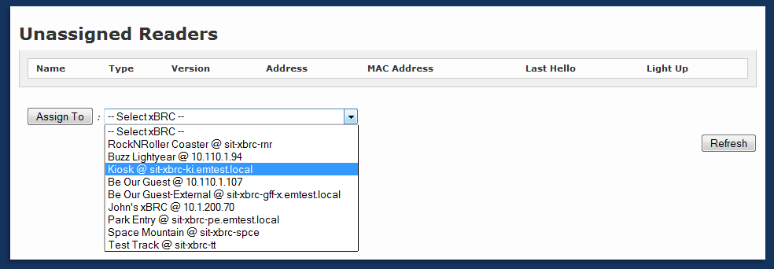

Figure 54: Unassigned Readers

## xBRC Configuration Edit

The xBRMS allows modifying parameters of running xBRC applications. To make configuration changes, each xBRC application to be configured must be currently running. The **xBRC Configuration Edit** page allows for modifying configuration for a single xBRC or multiple xBRCs.

The parameter changes are effective as soon as **Update Selected Xbrc(s)** is pressed. For most parameter changes, the xBRCs do not need to be restarted. The exception is the ESBInfo section settings. This section defines the JMS broker settings, and the xBRC must be restarted for changes to take effect.

The following figure shows the components of the **xBRC Configuration Edit** page.



Figure 16: xBRC Configuration Edit



Figure 17: xBRC Configuration Edit Expanded

To edit one or more xBRCs:

1. Select the checkbox for each of the xBRCs to modify.  
     
   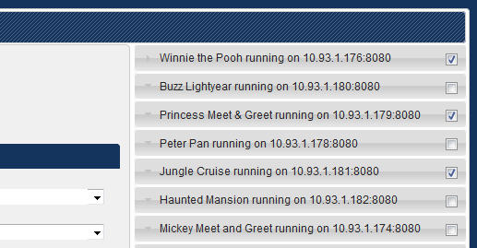

Figure 18: Configuration Edit – Selecting xBRC(s)

1. Make modifications to the configuration parameters.  
     
   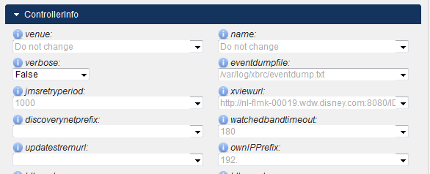

Figure 19: Configuration Edit - Modify Params

Note that when updating multiple xBRCs, the properties that are not the same for all the selected xBRCs will show the “Do not change” text.

1. Press **Update Selected Xbrc(s)** to save your changes.
2. If the ESBInfo section was changed, restart the xBRC(s).

## Stored XBRC Configurations

The xBRMS allows you to maintain a repository of xBRC configurations. Each xBRC configuration is an XML document containing the entire configuration for the xBRC. This includes the Mayhem.Config table entries, list of locations and list of readers at each location, and the configuration of the **Facility View**web page. It is also possible to store partial configurations containing a subset of the entire configuration. Currently, partial configurations must be edited by hand and uploaded as an xml file.

The **Stored XBRC Configurations** web page allows the following operations:

* Retrieval of full configuration from a running xBRC
* Uploading a configuration from an xml file
* Deploying a stored configuration to a running xBRC

The following figure shows the **Stored XBRC Configurations** page.

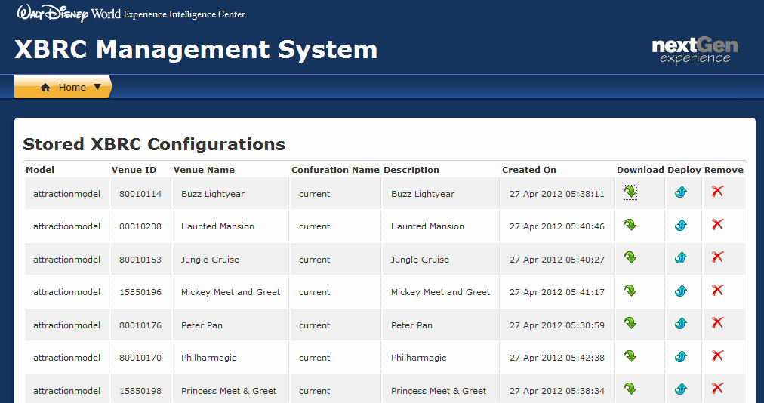

Figure20: Stored XBRC Configurations

### Adding New Stored Configuration

To add a new stored configuration to xBRMS:

Click **Add New** at the bottom of the page.  
 Figure 21: Monitored Readers Health Page – List View

1. The **Add XBRC Configuration** dialog will show.  
   
2. If uploading configuration from a running XBRC, click on the green refresh icon to auto-populate the form fields.
3. If uploading configuration from a file, select **Upload XML configuration file** and browse for the xml file on your local computer.
4. Enter the required form fields and click **Submit**to store the configuration in the xBRMS database.

### Deploying Stored Configuration

Deploying a stored configuration pushes all the settings from a stored configuration to a running xBRC. Some configuration changes may require the xBRC to be restarted depending on the differences between the current xBRC configuration and one being deployed. It is recommended to re-start the xBRC after a stored configuration is deployed.

To deploy a stored configuration:

1. Click the blue arrow icon on the right side of the stored configuration row.  
   
2. The **Deploy XBRC Configuration** dialog will show. A table with a description of the stored configuration is shown.  
   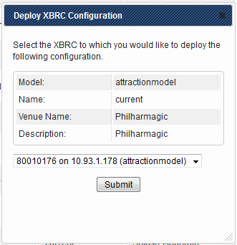
3. From the drop down list, select the xBRC to deploy the configuration to.
4. Click **Submit**.
5. Restart the xBRC. This step may be skipped if there are no significant difference between the current configuration of the xBRC and the configuration being deployed.

### Downloading Stored Configuration



Press the green arrow icon on the right side of the stored configuration row to download a stored configuration to a file on your local computer.

### Removing Stored Configuration

Press the red cross icon on the right side of the stored configuration row to remove a stored configuration from the xBRMS database.

## Edit XBRMS Properties

The **Edit XBRMS Properties** page allows for modifying of xBRMS configuration properties. Configuration properties which, according to NGE standards, must be encrypted and can only be specified in the environment.properties file, are displayed on a grey background and may not be changed. Note that some changes require xBRMS web server restart.

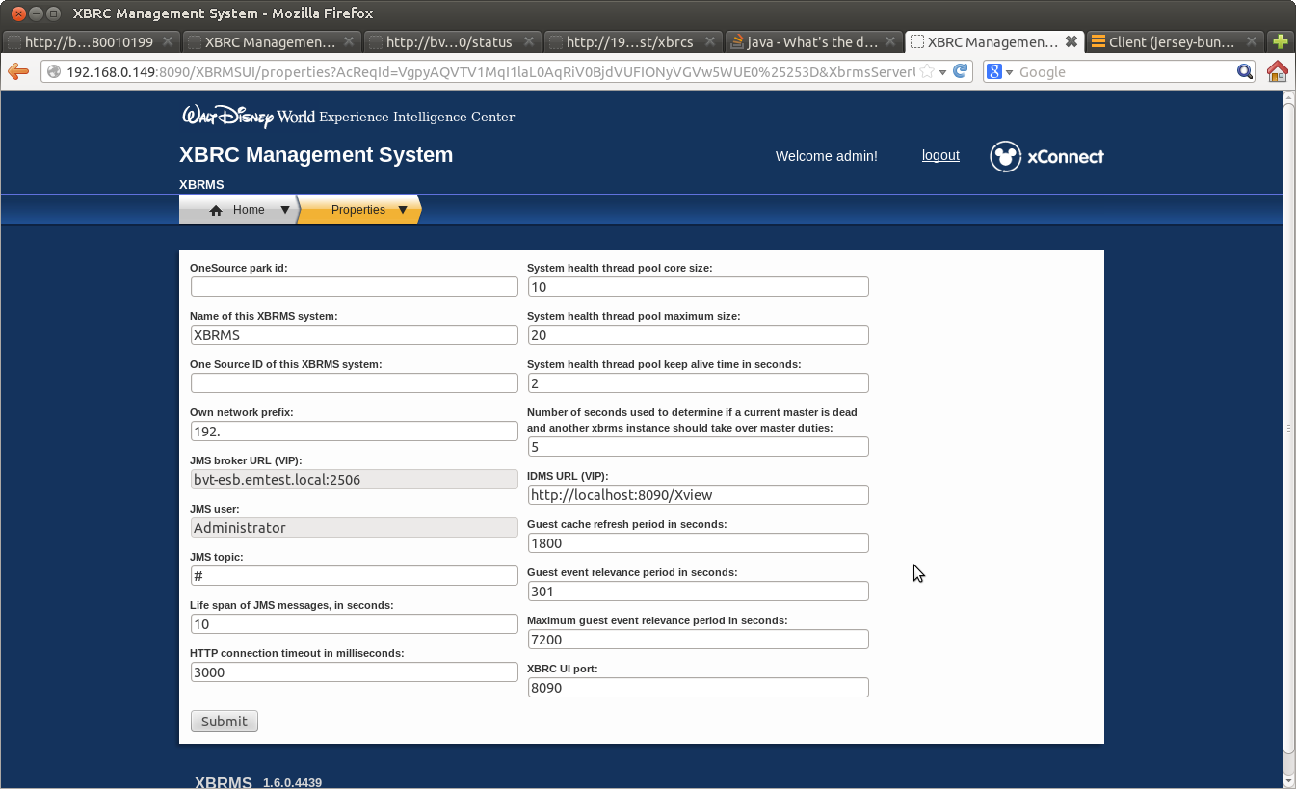

| **Column** | **Description** | **Requires Restart** |
| --- | --- | --- |
| OneSource park id | OneSource ID assigned to the park | No |
| Own network prefix | Network prefix of this xBRMS system | Yes |
| Life span of JMS messages | Life span of JMS messages in seconds | Yes |
| HTTP connection timeout in milliseconds | Timeout of HTTP connections | Yes |
| System health thread pool core size | Initial size of the connection pool used by the health monitor | Yes |
| System health thread pool maximum size | Maximum size of the connection pool used by the health monitor | Yes |
| System health thread pool keep alive time in seconds | Keep alive period for determining if a pooled connection is alive | Yes |
| Number of seconds used to determine if the current master is dead | Number of seconds before HA failover takes place when the current master is detected to be dead (unresponsive). | Yes |
| JMS broker URL (VIP) | The Sonic MQ JMS broker URL in the form <ip>:<port>. Virtual IP is expected. | Yes |
| JMS user | Username to be able to connect to the Sonic MQ JMS broker. | Yes |
| JMS topic | Default: com.synapse.xbrc. This is the topic on which the DISCOVERY message is sent from the xBRC. | Yes |
| Name of this XBRMS system | This name is passed to other system in the /rest/facilities REST call. | No |
| IDMS URL | URL of the IDMS system. | No |
| Guest Cache Refresh Period in Seconds | How long to keep cached guest information obtained during the Guest Search operation. | Yes |
| Guest event relevance period in seconds |  |  |
| Maximum guest event relevance period in seconds |  |  |
| XBRC UI port | The web server port of the XBRC UI web service. Default: 8090 | No |
| One Source ID of this XBRMS system |  | No |

## XBRMS server chooser

If the XBRMS UI application is configured to serve multiple parks, you will see the following screen on successful logon.

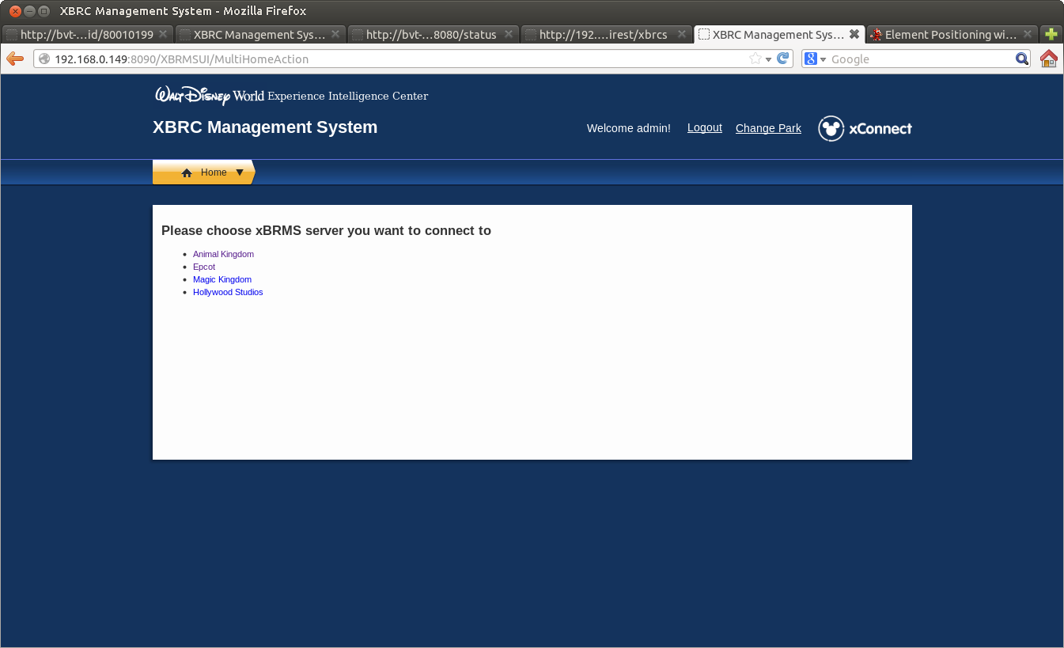

In order to connect to an XBRC server dedicated to a specific park, clink on one of the links in the parks list. You can always change your selection by clicking on the “Change Park” link in the upper right corner of the screen. Note that if you run XBRMS UI in multiple web browser tabs, your choice of the server will make the UI in all the tabs switch to the chosen server.